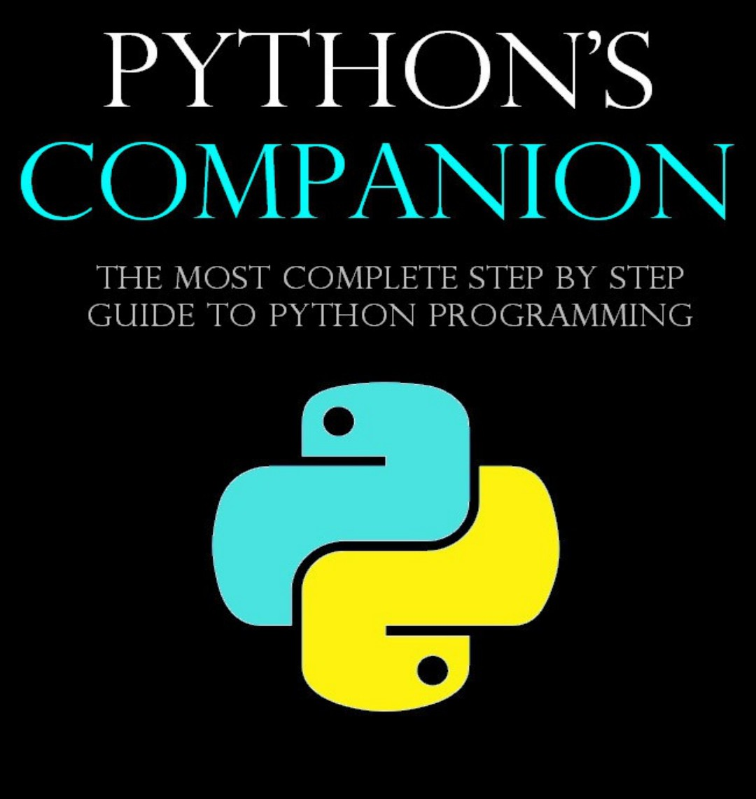
Pythons Companion
The most complete step-by-step guide to python programming.

JOSEPH KITUTU,S BOOK

COPYRIGHT
2025 JOSEPH KITUTU-ALL RIGHTS RESERVED.
This document is geared to providing exact and reliable information in regards to the topic and issue covered.The publication is sold in the idea that the publisher is not required to render accounting,officially permitted or otherwise,qualified services.If advice is necessary,legal or professional,a practiced individual in the profession should be ordered.
From a declaration of priciples which was accepted and approved equally by a committee of the American Bar Association and a Committee of publishers and Association.
In no way is legal to produce,duplicate,or transmit any part of this document in either electronic means or printed format.Recording of this publication is strictly prohibited and any storage of this document is not alloud unless with written permission from the publisher.All rights reserved.
The

